Web Designing Assignment

Module (HTML) -1

1) Are the HTML tags and elements the same thing?

- HTML Tags are building blocks of HTML Page.

- HTML Elements are components that are used in HTML Page.

2) What are tags and attributes in HTML?

- HTML tags are used to hold the HTML element.

- HTML element holds the content.

- HTML attributes are used to describe the characteristic of an HTML element in detail.

3) What are void elements in HTML? With Example

- A void element is an element whose content model never allows it to have contents under any circumstances.

-<area> - <input>

- < base> - <keygen> -

- <wbr> - <img>

- <br> - <track>

- <col> - <link>

- <command> - <meta>

- <embed> - <param>

- <hr> - <source>

EX:-

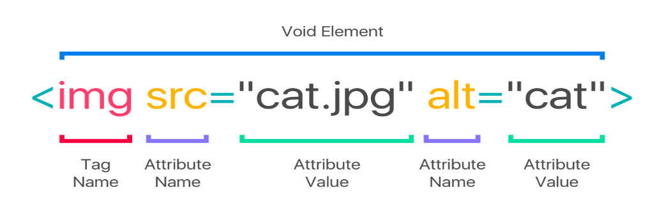

4) What are HTML Entities? With example.

* <(less than) =&lt;
* >(greather than) = **&gt;**

EX:-

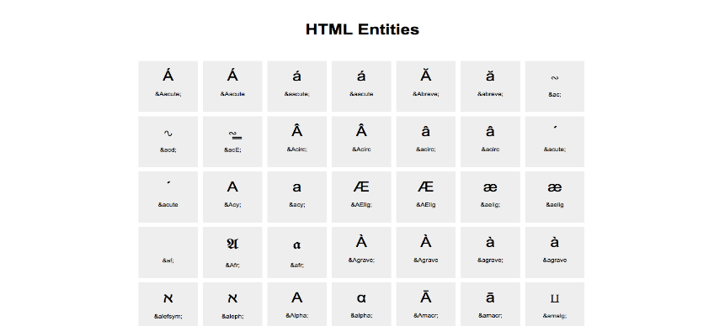

5) What are different types of lists in HTML? With Example.

- HTML lists come in three main categories:

* unordered lists

EX:-

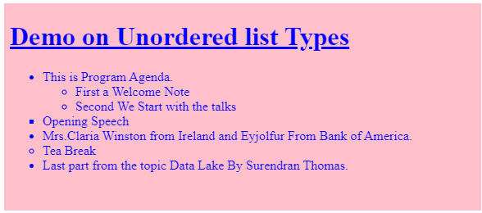

* ordered list

EX:-

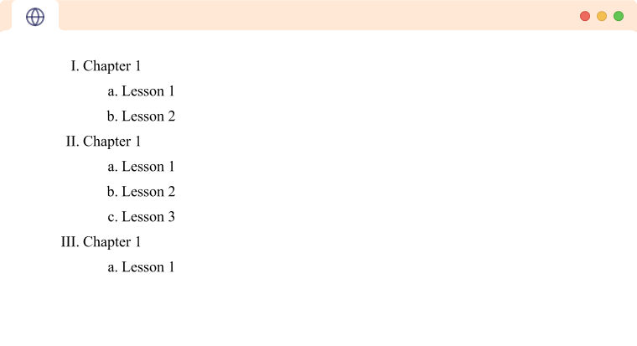

* Difinition list

EX:-

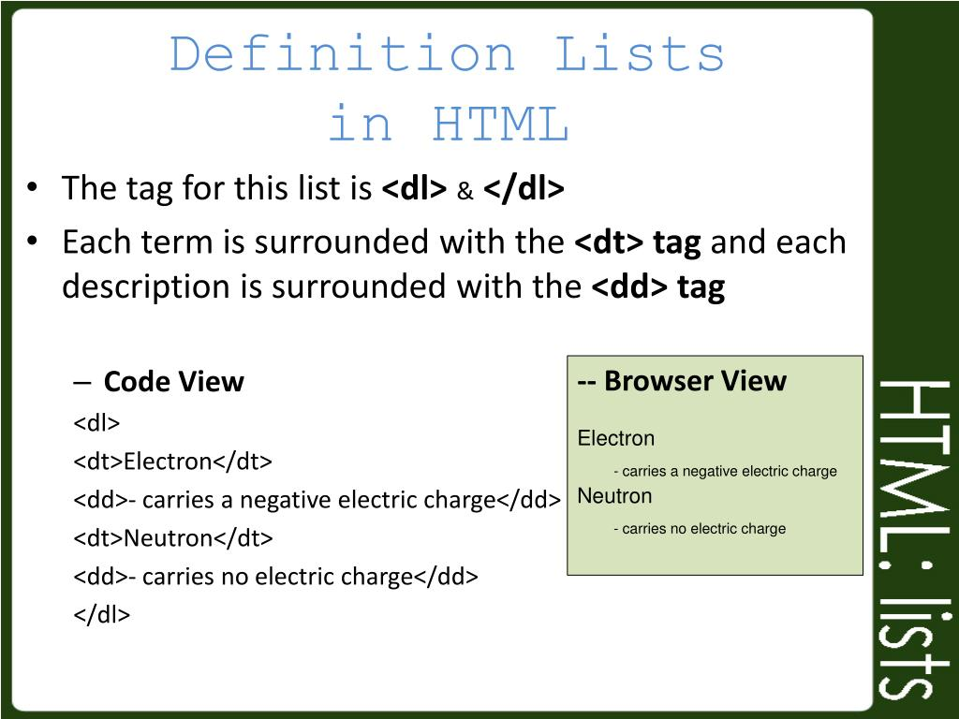

6) What is the ‘class’ attribute in HTML? With example.

- The class attribute specifies one or more class names for an elements.

EX:-

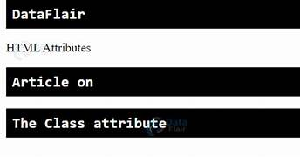

7) What is the difference between the ‘id’ attribute and the ‘class’ attribute of HTML elements?

- The basic difference between ID and Class is that the ID selector is applied only to one element in a page, whereas the class selector can be applied to several elements on a single page.

EX:-

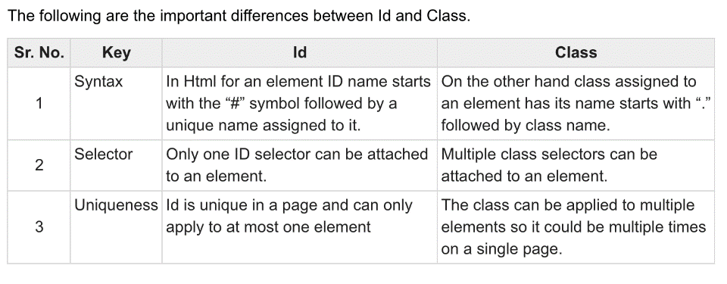

8) What are the various formatting tags in HTML?

* <b> bold text
* <strong> important text
* <i> italic text
* <em> emphasized text
* <mark> marked text
* <sup> superscript text
* <sub> subscript text
* <small> smaller text
* <del> deleted text

9) How is cellpadding different from cellspacing? With example.

- cellspacing is used to set space between ceels.

- cellpadding is the amount of space between the outer edges

Of the table cell and the content of the cell.

* Cellspacing is the amount of space in between the individual table cells.

EX:-

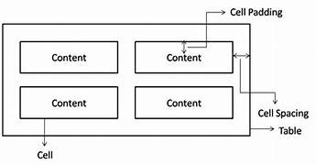

10) How can we club two or more rows or columns into a single row or column in an HTML table? With example.

- we use the colspan and rowspan attribute to merge cell in HTML:

- The rowspan attribute is for the number of rows a cell should merge, whereas the colspan attribute is for the number of columns a cell should merge.

-The attribute should be placed inside the <td>tag.

EX:-

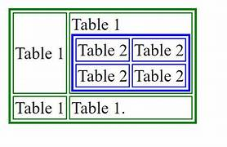

11) What is the difference between a block-level element and an inline element?

- Inline elements never begin on a new line. Block elements completely fill the accessible area from left to right.

12) How to create a hyperlink in HTML? With example.

- The most important attribute of the <a> element is the herf attribute,whice indicates the link’s dwstination.

- the <a> tag defines a hyperlink, which is used to link from one page to another.

EX:-

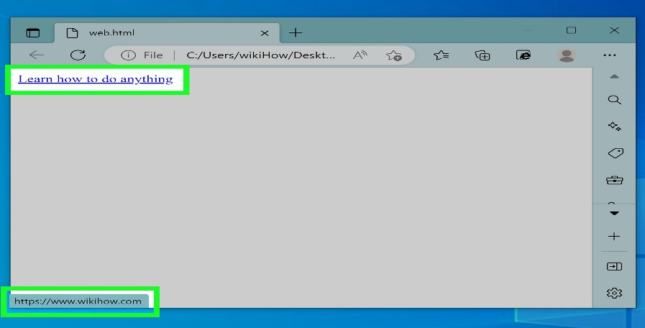

13) What is the use of an iframe tag ? with example.

- An inline frame is a html element that loads another html

Page within the document.

EX:-

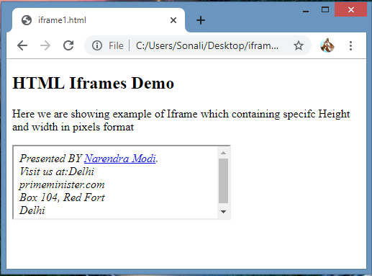

14) What is the use of a span tag? Explain with example ?

-The span tag is a generic inline container elements. You use this elements to wrap sectoin of text for styling purposes or to add attributes to a section text without creating a new line of content.

EX:-

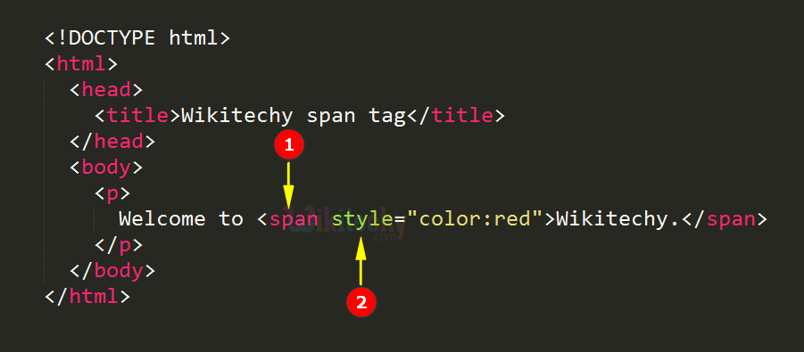

15) How to insert a picture into a background image of a web page? With example.

- within the starting <body>tag in your HTML file type <body background- image:radialgradient(….,….,…,)>

EX:-

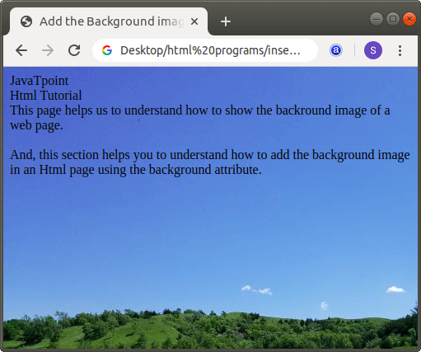

16) How are active links different from normal links?

- Active links are typically that are currently functional and lead to live web pages,while normal links can refer to any link, whether functional or broken.

- links help you to get information from different resoures.links are established in simple HTML web pages through <a>tag.

17) what are the different tags to separate sections of text?

- The body tag used for text and tags that are shown directly on your web page.

18) What is svg?

- SVG stands for scalable vector graphics.

- SVG is used to define vector-based graphics for the web.

- SVG defines graphics in HTML format.

- Each element and attribute in SVG files can be animated.

19) what is difference between HTML and XHTML?

-HTML (Hyper text markuo language) and XHTML (Extensible hypeer text markup language) are both markup language used for creating and displaying web pages. The main difference between them is the syntax and structure;HTML is more lenient in its syntax, while XHTML has a more strict syntax and follows XML rules.

20) What are logical and physical tags in HTML?

=> In HTML the formatting tags are divided into two categories :

Physical tag: these tags are used to provide the visual appearance to the text.

Locial tag: these tags are used to add some logical or semantic value to the text.